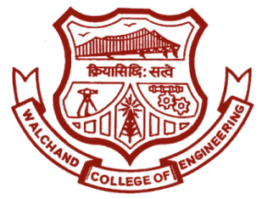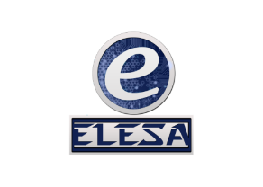 WALCHAND COLLEGE OF ENGINEERING, SANGLI

**ELESA**

**ELECTRONICS ENGINEERING STUDENTS’ ASSOCIATION**

E-mail : walchand.elesa@gmail.com Website: www.elesa.in

**Date:- 12/02/2018**

**SECRETARIAL REPORT ON**

**ROBOHOLIC**

This was one of the most remembered, one of the most appreciated event of ELESA. The new year, the new sem of the year started with a bang. Assistant Board of ELESA organized ROBOHOLIC- a robo war event for the first time in ELESA history which eventually had management too. 52 entries from F.Y. to B.Tech for this event were registered. B.Tech Members were made mentors. Overall there were 4 teams which had it’s own 2 mentors. Profiles of students from F.Y. to T.Y. were taken on the basis of which auction was carried among mentors to form there team. Each team had 13 members along with mentors.

After the teams were formed principal components required to form the robot were provided to each team by the organizing committee. They were given a span of 10 days to form there robot after which ROBOWAR took place. Teams were provided with dimensions to form there robot without which they had to renovate their bots. The main event took place before the Walchand crowd in front of the steps on 10th and 11th February. Four teams named Megatron, Kryptoknights, CyberKnights and Competed amongst each other to win the title.

The matches took place in front of the steps for two consecutive days after which Krypoknights emerged as the winner winning the final match against Cyberknights. Organizing Committee as well as the participants along with the crowd was very active in cheering and encouraging their respective teams. Certificates along with medals were distributed to participants and the event concluded with the same.

Mr. Ajit Sanjay Attarde Joint Secretary, ELESA